Geek Squad Sick Computer Log  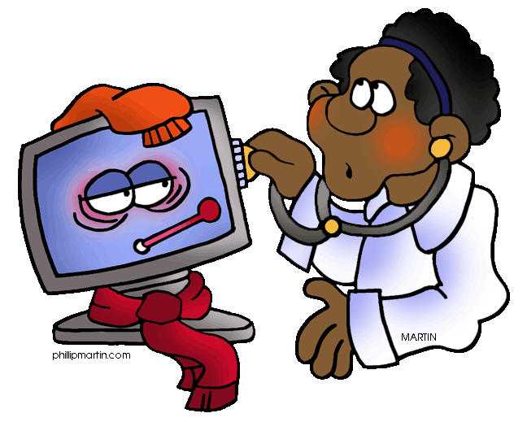  Team: If you see a sick computer on your rounds please scan the QR code below and report it to the computer doctor. | Geek Squad Sick Computer Log  Team: If you see a sick computer on your rounds please scan the QR code below and report it to the computer doctor.
Geek Squad Sick Computer Log  Team: If you see a sick computer on your rounds please scan the QR code below and report it to the computer doctor. | Geek Squad Sick Computer Log  Team: If you see a sick computer on your rounds please scan the QR code below and report it to the computer doctor.

